SDGs × Fast fashion

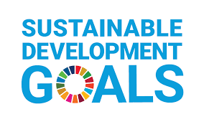
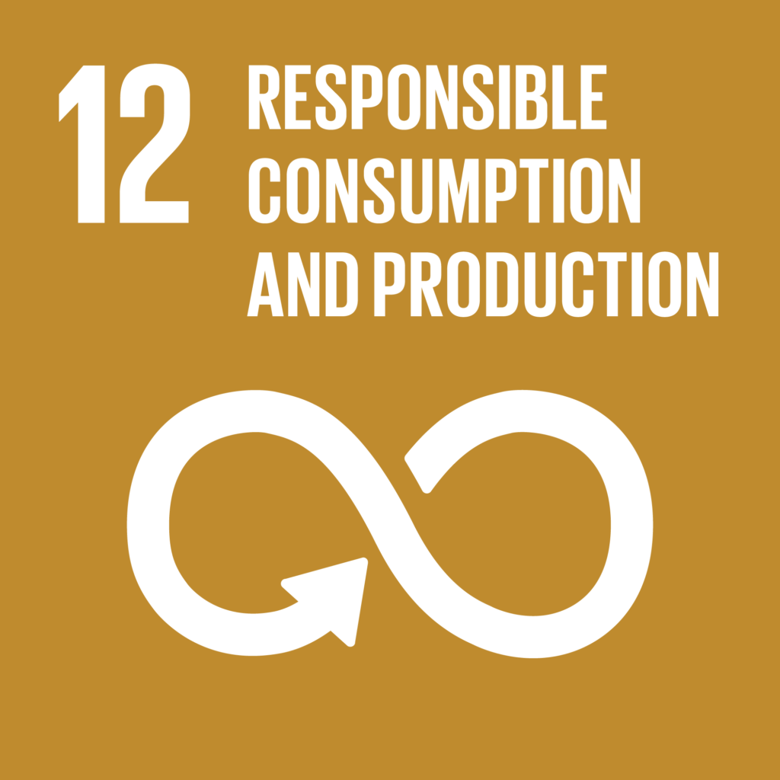

60 mins

Step 1 BEFORE WE START
The following picture shows the textile mountain. What can you tell from the picture? Discuss with your partners for 5 mins.

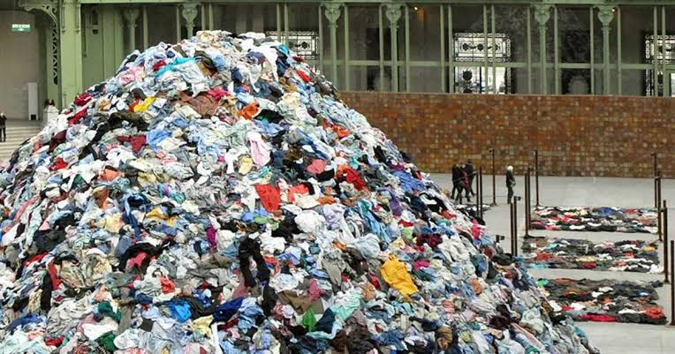

Step 2 BASIC INFORMATION
1. Watch this video below(watch the first 1:10 mins) and then complete the sentences with the words and phrases from the box.
Fast Fashion Explained In Under 5 Minutes

new cheap new items Fast fashion different styles stay on trend trendy
replenishing their stock trendier unfashionable outdated

______ is the term used to describe ______ and ______ clothing which are very quickly changing in and out of style. Many fast fashion retailers introduce new products multiple times in a week in order to ________. Instead of __________, they replace the items that sell out with ________ of __________, making the older clothing ______ and ________and also making us constantly want to keep shopping for ______ and ______ clothing.

2. Read this paragraph below and write T(true) or F(false).

Over the last few centuries, as the world has changed, there were also dramatic changes in our relationship with clothing. It starts from an era when the clothing was bespoke or tailor-made to the ready-to-wear era and to the current era of fast fashion. There are four major points we want to pose about fast fashion. Firstly, companies do it all in-house from design, manufacturing and selling clothing which helps streamline cost and optimize production process. Secondly, fast fashion is all about the communication between designers and customers. Designers receive data on what sells and what doesn't as often as daily and also conduct field research on what is trending. Thirdly, the emphasis is on fast and how much time it takes to make clothing is now a fraction of what it once did. Finally, fast fashion is dependent on cheap labor.

___ 1. Relationships between people and clothing started with the ready-to-wear era.
___ 2. The clothes design were all created in house in the fashion industry.
___ 3. The designers don't care what is trending.
___ 4. How much it takes to make clothing is strongly emphasized in fast fashion.
___ 5. Fast fashion is dependent on cheap labor.

Step3 EFFECT OF FAST |FASHION

Part A
Discuss with your partner for 5mins;“How fast fashion can affect society?”

Part B
Watch this video(watch from 1:10 mins) and answer the questions.
Fast Fashion Explained In Under 5 Minutes

1. Answer the following questions.
1)What makes fashion brands steal and copy ideas from independent artists?

2)What is a word which means a factory or workshop where manual workers are employed under poor conditions?

3)Which country has been shown as an example of a sweatshop?

4)What colours can toxic chemicals enable to create?

5)How much landfill is used for textiles?

2. Complete the sentences with the words and phrases from the box.
70 disposable greenhouse gas polluting second chemicals

Fast fashion has a huge impact on the environment. Garment production and unregulated factories often use toxic ______, which can harm workers and are dunked into streams and rivers ______ the water and soil.
Because fast fashion is cheap and ______, consumers are throwing their clothes away very easily. On average, US citizens alone throw away ______ pounds of clothing every year.
According to a report, the textile industry emits more ______ emissions than international shipping and aviation combined. Some reports even claim it’s the ______ dirtiest industry in the world.

Step4 HOW TO DEAL WITH FAST FASHION
Part A
Discuss with your partners for 5mins;“How can we cope with fast fashion?”

Part B
Watch this video below(watch from 5:50 mins)and then fill in the blanks.
I Broke Up With Fast Fashion and You Should Too | Gabriella Smith | TEDxWynwoodWomen

Women's experience
The best way to do something for fast fashion is to _____ _____ _____. Which was translated to __________ to her. It was easier for the woman to ______ something new than to ______ something that she already had in her closet. Clothes in the woman’s closet had just ______ clothes.

In general
Nobody truly cares about ______ fast fashion. They wore the clothes because they wanted to look ______. We have to think what we can ______ from clothes, what is the ______, who ______ them. Is the brand story aligned with the value I think?
--no. The clothes had nothing better than the ______ and the ______.

*ADD = attention deficit disorder

From the publisher
We have to think which clothes are necessary and which are not. Please think if those clothes are really important for you. More you purchase fashionable clothes, the more someone may suffer. We have talked about the problems of fast fashion but, we do not think fast fashion is bad.
I want all the people to cherish their belongings and use them until it cannot be worn in daily lives.

Answer for teachers
Step 2
1.
Fast fashion is the term used to describe cheap and trendy clothing which are very quickly changing in and out of style. Many fast fashion retailers introduce new products multiple times in a week in order to stay on trend. Instead of replenishing their stock, they replace the items that sell out with new items of different styles, making the older clothing unfashionable and outdated and also making us constantly want to keep shopping for new and trendier clothing.
2.
F 1. Relationships between people and clothing started with the ready-to-wear era.
T 2. The clothes design were all created in house in the fashion industry.
F 3. The designers don't care what is trending.
T 4. How much it takes to make clothing is strongly emphasized in fast fashion.
T 5. Fast fashion is dependent on cheap labor.

Step 3
Part B
1. 1)New trends
2)sweatshop
3)Bangladish
4)vibrant colours
5) 3/4
2.
Fashion has a huge impact on the environment. Garment production and unregulated factories often use toxic chemicals, which can harm workers and are dunked into streams and rivers polluting the water and soil.
Because fast fashion is cheap and disposable, consumers are throwing their clothes away very easily. On average, US citizens alone throw away 70 pounds of clothing every year.
According to a report, the textile industry emits more greenhouse gas emissions than international shipping and aviation combined. Some reports even claim it’s the second dirtiest industry in the world.

Step 4 Part B
Women’s experience
1. nothing at all
2. stop shopping
3. buy
4. rewear
5. trendy

In general
1. sustainable
2. cute
3. value
4. purpose
5. made
6. style, price

