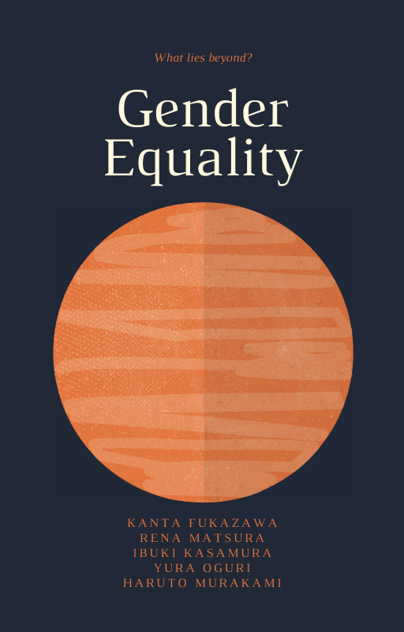

This textbook will take about one-hour to complete !

- The History of Gender equality

Women have struggled for equal rights for centuries.

As a precondition, in ancient world, women are thought by majority to be like following,

Christianity: Martin Luther, who established the protestant in the christianity said that girls can grow faster than boys physically and mentally, but it is the same as weed grows faster.

Islam : Men have an extremely strong right to women. For example, men can marry a number of women even though women can not. To my surprise, in islamic world, they think of women as a potential threat which can collapse the morals of the world.

Buddhism : There are several discriminations in the vibes of buddhism. For example, however hard women make an effort in order to be a Buddha, they never are. This is just a rule, not a theory. Other than that, it is thought that women should follow what men do or say. As these examples indicate, it is commonly thought that women are inferior to men as if it is natural.

------------------------------------------------------------------------------------------------------------------------

However, since the 19th century, a remarkable movement which aims to improve women’s rights had started. In 1848, the Declaration of Sentiments was signed at the Seneca Falls Convention where women activists publicly petitioned for civil, social, political and religious rights. 15 years later, due to this declaration, New Zealand sent a message to other activists across the world that equal voting rights were achievable through advocacy.
In the 20th century, women around the world were mobilizing in ever greater numbers for gender equality. For example, the first International Women’s Day is marked in Europe. At the same time, women’s role in the labor force is rapidly evolving because of the movement in Japan. In 1945 when the United Nations was formed, they adopted the Universal Declaration of Human rights. After that, several foundations for women’s rights norms and standards were established worldwide. In 1995, the Beijing Declaration and platform for action presented a visionary global agenda for women and girls rights. Subsequently, not only women, but also men began to participate in those movements or set out new organizations in this digital era.. To name a few, Feminism and #Metoo.

Q1. How were women considered in the ancient world?

Q2. Who adopted the Universal Declaration of Human Rights?

Q3. What is the contents of the Beijing Declaration?

Q4. What activity for gender equality do you know?

Answer :
Q1 : Women were considered to be inferior to men.
Q2 : The United Nations did.
Q3 : The content was for action presented a visionary global agenda for women and girls right.
Q4: ex) Malala Yousafzai acts for girls' education rights.

History of gender inequality in Japan

Japan has a long history of gender inequality. How are women's rights admitted in history? Who was the person to struggle with the issues?

Meiji Period
Under the Kiyotaka Kuroda administration, the House of Representatives Election Law was passed. However, the law did not admit women's rights to vote and eligibility for election. In the next year, women were prohibited from participating in political meetings and associations. New Civil Law that stressed rights accruing to the head of a household in 1890. Also, according to this law, the heir had rights to obtain inheritance. Security Police Law which banned women from joining political meetings and associations was announced in 1900 as well as in 1890. Akiko Yosano who was famous for her poem called ‘Kimi Shini Tamahu Koto Nakare’ (Don’t die) recited women's independence for economical and personal reasons. Factory Law, which was the first workers protection system in Japan, was announced in 1911. This law determined that restriction of work hours for women, and ban of midnight work. In the same year, Raicho Hiratsuka as a leader organized Seitosha. She stated that mothers and children should be given life security from nations.

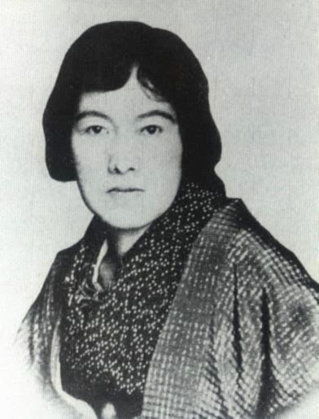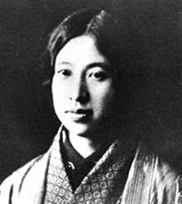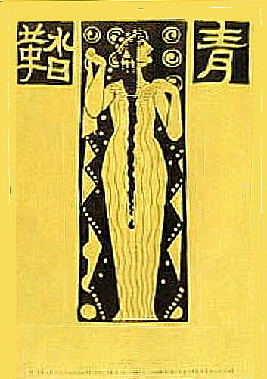
▶︎Akiko Yosano(1) ▶︎Raicho Hiratsuka(2) ▶︎『Seito』(3)

Taisho Period
Women including Raicho Hiratsuka and Husae Ichikawa formed the New Women’s Association to amend the Security Police Law in 1920. In the next year, Kikue Yamakawa, Noe Ito and so forth organized the Red Wave Society. In 1922, the fifth of Security Police Law was amended due to the New Women’s Association, and women were allowed to participate in political meetings. Husae Ichikawa established the Women's Suffrage Acquisition Period Alliance.

Showa / Heisei Period
Security Police Law was abolished in 1945 by GHQ. In the same year, the House of Representatives Election Law was amended. This meant women’s rights to vote and eligibility for election were admitted. As a result, 39 female lawmakers were born in the next year. In the same year, 1946, the Constitution of Japan which included protection of gender equality was announced. In 1947, Civil Law was amended. In this amended law, inheritance was given equally regardless of gender. Japan concluded Convention on the Elimination of All Forms of Discrimination Against Women which aimed to remove discrimination of various aspects like policial, social, and economical in 1985. In the next year, the Equal Employment Act was enforced to realize gender equality in employment. In 1999, the Basic Act for Gender Equal Society was enforced. It enabled society to reflect gender equality.

Questions
Q. Match each of the following statements with the correct law, A-D. You can choose each law more than once.
- It determined that restriction of work hours for women.
- In 1945, it was abolished by GHQ.
- It banned women from voting at first.
- It was amended due to the New Women’s Association in 1922.
- In 1947, it admitted inheritance for women as well men.
- It enabled female lawmakers to be born in 1946 after being amended.
———————————————————
A House of Representatives Election Law
B Factory Law
C Security Police Law
D New Civil Law
———————————————————

Q. Do the following statements agree with the information in the passage?
For questions 7-9, you should write

TRUE If the statement agrees with the information
FALSE If the statement contradicts the information

- Akiko Yosano wrote a poem which is called ‘Kimi Shini Tamahu Koto Nakare’.
- Noe Ito is one of the women who contributed to form the New Women’s Association.
- The Equal Employment Act was enforced in 1999.

1. | 6.
2. | 7.
3. | 8.
4. | 9.
5. | /

Answers
- B
- C
- A
- C
- D
- A
- TRUE
- FALSE (Noe Ito→Raicho Hiratsuka or Fusae Ichikawa)
- FALSE (1999→1986）
Work Opportunities

According to the World Economic Forum's global gap report, in 2020, Japan ranked 121th out of 153 countries. In 2019, Japan ranked 110th while it was 80th in the first year.​​ The gender gap is becoming wider than before. In fact, there were only 2 women in Suga's cabinet. According to the world economic report, in 2013, Prime minister Abe set the goal to improve women's rights and declared he achieved a society which is " A japan in which women can shine". However, there is still a wage gap between genders. Until 1990th, women could get only 60% of the wages of men. From this, many people think that the stereotype of women has to rely on men. It is still only 75% and it is not equal. Also, administration jobs tend to be controlled by men.
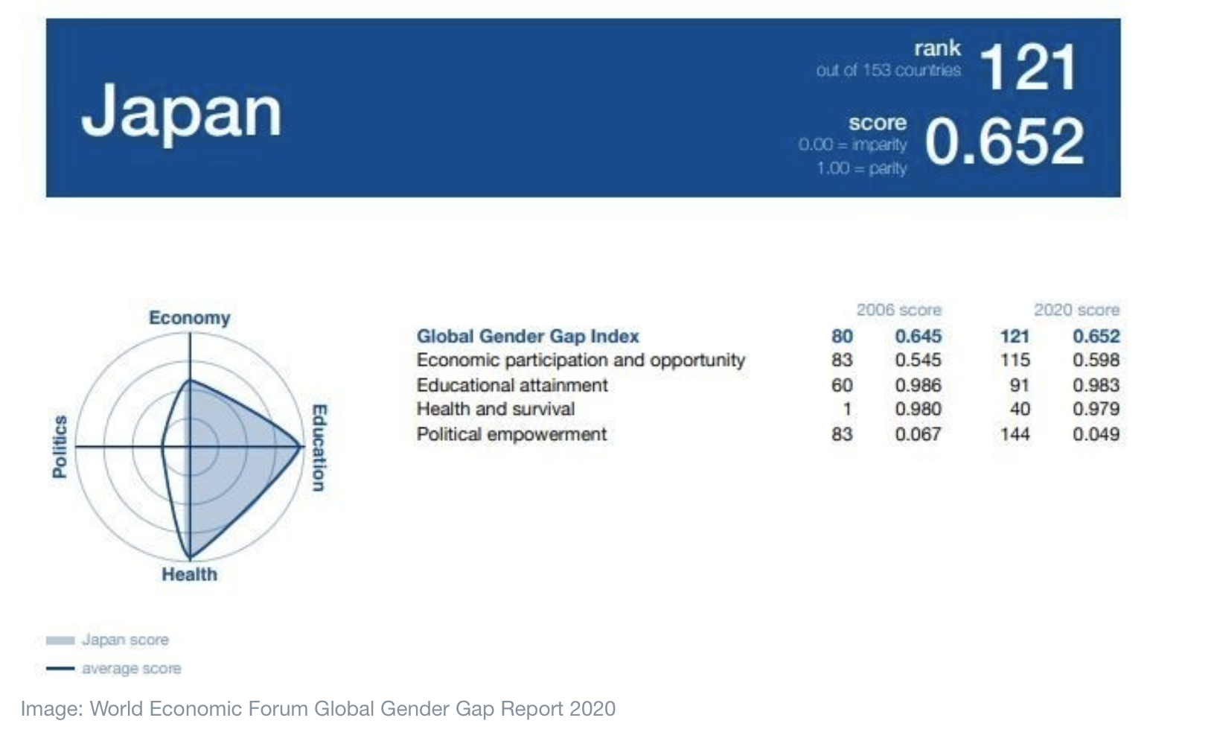
According to the IPU research, the number of women in the house of representatives is 9.9% while haif of the nation is women.

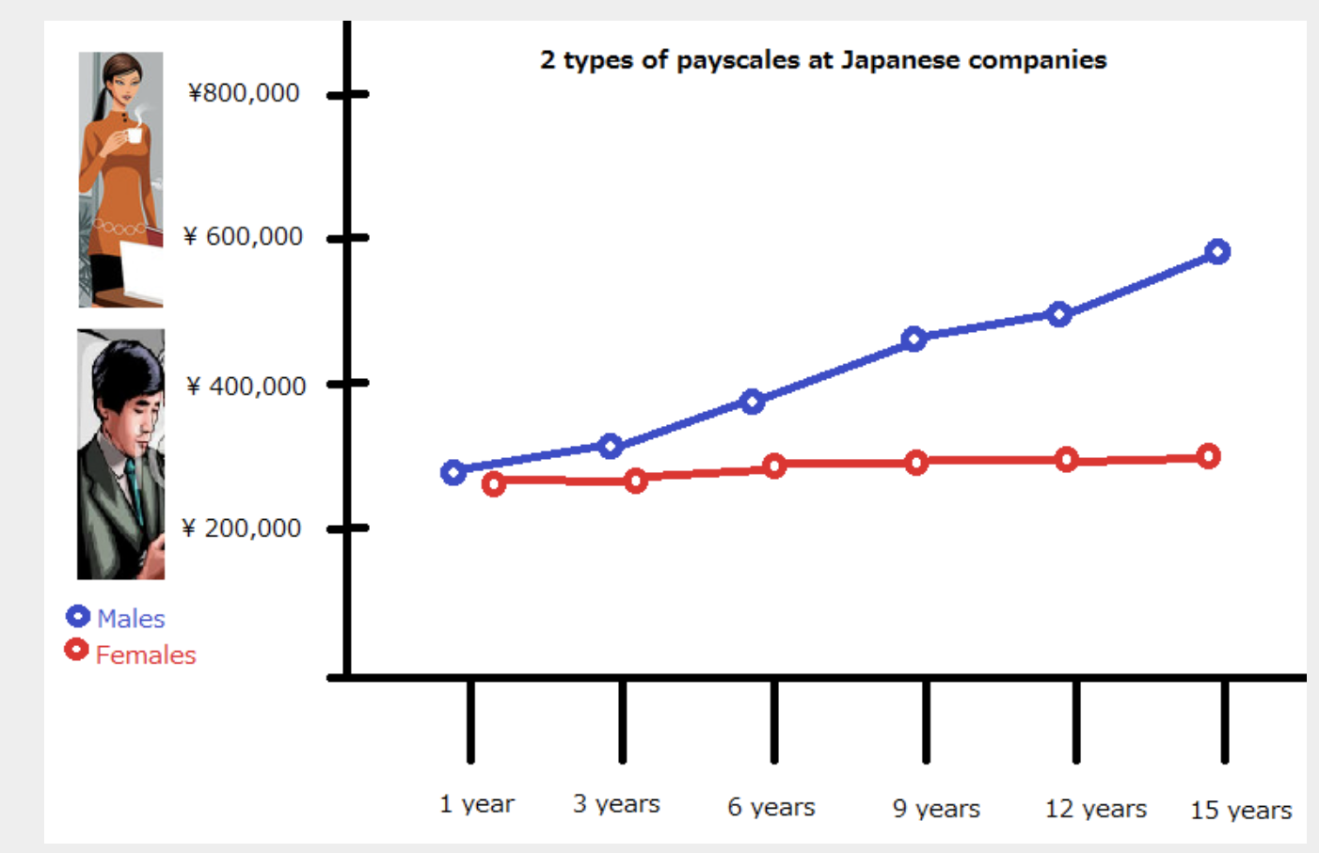

For row, the basic act for gender equality went into effect in June 1999. From this more women have opportunities to work.​​​​ However, in 2008, about 50% of working women were irregular employees.In addition, the number of two-income families is increasing. However, the law work -life balance of women is not perfect right now. Japan scored highest for paternity leave.
In contrast, only 5% of Japanese fathers took any of it. Many people still think that women and men's household time is only 30 min. Internationally, women spend more time doing chores.
The survey reveals other results that men sleep 9hours and 33 minutes on average. On the other hand, women sleep 8 hours and 33 minutes. If the law or support changed, society would still have many differences in working styles between men and women.

=======================================================================
Questions
Look at questions 1-3 below and answer them.

1.According to the gender gap report in 2020, where did Japan get in?
2.How many women were included in Suga's cabinet?
3.How long men spend on household work on average?

1.121th / 2. Only 2 / 3. Only 30min.

Do the following statements agree with the information given in the reading passages?
Write TRUE/ FALSE / NOT GIVEN.

1. Most women work the same jobs as men.
2. Men mostly do household work recently.
3. Everyone thinks men should take responsibility for their family.
4. Japan became one of the gender equal countries.

1. FALSE /2.FALSE/ 3.NOT GIVEN /4.FALSE

The Most Kind Country to Women; Sweden
According to the gender gap( Japan Times, 2019) Sweden ranked 4 in 2021 and 3 in 2018. The European Institute for Gender Equality published this data. It shows that 33.7 of men in EU countries share housework. On the other hand, 56 % of men in Sweden do and 74 % of women do. That is, the gap between them is getting smaller so we can say gender inequality on dometic fields proving in Sweden. Sweden made this situation possible from a political dimension.
They declared Swedish Gender Equality Acts in 1979 and it contained ‘Separate Income Taxation for Wife and Husband’, ‘Development of Public Child Care’, Gender-neutral paid Parental Leave Benefit’ and ‘The employment of Rate of Women’. The first one ‘Separate Income Taxation for wife and husband’ and third one ‘Gender-neutral paid Parental Leave Benefit’ are the causes of gender equality in the domestic field.
1) Separate Income Taxation for wife and husband is an act which encourages wife to take part in the labour market. Wife’s income is not considered as a part of husband’s income. Individual tax propels each of them to work. This act could cover gender equality in employment. What if both of the parents devote their lives to their job and children get sick so one of them has to take off, one would be wife again? To avoid this inequality, Swedish governments started a reserved month from 1995. It was a month for each from 1995, second months from 2002, and third months for each from 2016. Today, both parents are able to serve 480 days of paid parental leave (4 months). This amounts of days of paid parental leaves entitled to both parents improved gender inequality on domestic fields,

Check key points!!
1)Separate income taxation for wife and husband
2)Development of public child care
3)First country to introduce gender-neutral paid parental leave benefit
4)The employment rate of women
1) Wife’s income is not considered as a part of
( a-1)_________ income, which
encourages both of parents to do a job and earn money. This fixes the _______ rate of women.
2) Both wife and husband can apply to (b-2) ______ _____ , wife is not required to take off. Today, both of them can have up to (b-3)____ days, which is 4 months.
(a-1) husband
(a-2) employment
(b-2) parental leave
(b-3) 480

The current situation of gender gap in Iceland
The country "Iceland" is well known for being advanced in gender equality. According to the Global Gender Gap Report 2021, Iceland is the most gender-equal country in the world for the 12th time while Japan is ranked as 120th out of 156 countries in the world. ( 2021, WORLD ECONOMIC FORUM) Therefore, it can be said it is worthwhile acquiring knowledge of what caused Iceland to succeed in fulfilling one of the worldwide issues of "gender equality" as Japanese.

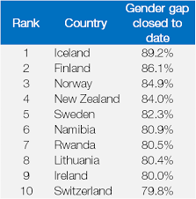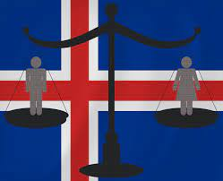

A: Discuss these questions with your peers !

1. What do you think of Japan being ranked in the low position for gender equality? How do you think we should work on this issue?

2. What do you know about Iceland?

The background of Iceland's gender equality in cultural and religious fields
A notion of "strong women" had an impact on Iceland to be a global leader of gender equality. Women took pleasure in certain liberties and had cultural and religious authority during the commonwealth period. To take it further, there used to be gods and goddesses, as well as women and men serving as cultural and religious authorities. Women were priestesses and oracles, poets and rune masters, merchants and medicine doctors, enjoying respect in society .Meanwhile, this religious diversity ended with the advent of Christianity when the diverse group of Gods and Goddesses was replaced by one monolithic God. This caused women to no longer be considered "good enough" to publicly symbolize God. In addition, women did not have the right to vote or to be represented in Iceland’s parliament.

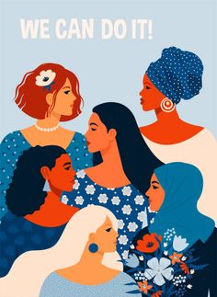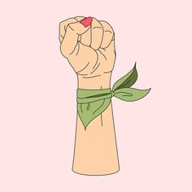

B: Check your understanding!

1. What is considered to give an impact on Iceland's success in gender equality in aspects of the cultural field?

2. What period did women have cultural and religious authority?

3. What caused women to lose their respect?

The history of women's political presentation in Iceland
Women began to fight to be good enough. They partially achieved this when they were given the right to be Protestant priests, and vote and run as political candidates around 1914 and 1915. However, with a huge difference between right based law development and prevalent cultural norms, the unequal-gender gap situation did not change until feminism became a huge movement in the 1960s and 1970s. This strengthened the unity of women for equal rights and influenced politics. During these decades, Feminism began to infiltrate theology with God referred to as She by the first woman ever to be inaugurated as a priest in Iceland in 1974.

Between the period from 1915 to 1983, only 2%-5% of Parliament members were women. In 1983, there was a significant rise in the number of women in parliament for the first time in Icelandic history. As time went on, women's issues were led to the political subject of other parties and women in these parties started to carry a more significant role. During the century that has passed since women got national suffrage, the number of women running as candidates for elections has increased. However, equal sex propotion still does not reach the goal of fullfillng gender equality in political fied. In order to reach the goal, women have to be placed high(er) on the list of candidates to have an equal chance to be elected into power.

In 2016, women accounted for 48% of elected representatives in parliament. After more than 100 years, there is almost political equality. The country "Iceland '' has developed its gender equality through a long period of history and the women's hardships.

C; Check your understanding!

1. When were women given the right to be Protestant priests and vote, run as political candidates?

2. What created a huge movement in the 1960s and 1970s?

3. When did women become the first ever to be inaugurated as a priest in Iceland ?

4. What percentage of women in Iceland accounted for parliament between 1915 and 1983?

5. What proportion of women were accounted for elected representatives in parliament?

---------------------------------------------------------------------------
Answer
B;
1. A notion of "strong women"
2. The commonwealth period.
3 . The advent of Christianity (when the diverse group of Gods and Goddesses was replaced by one monolithic God)

C;
1. Around 1914 and 1915.
2. Feminism
3. In 1974.
4. 2%-5%
5. 48%

------------------------------------------------------------------------------------------------------------------------

Watch Ted talk below and fill the blanks!!

Ted talk: Why is gender equality good for everyone?- men included
Transcript of "Why gender eqded"uality is good for everyone — men inclu

We would read some text in feminist theory and have a conversation about it. And during one of our conversations, I witnessed an interaction that changed my life forever. It was a conversation between two women. One of the women was white, and one was black. And the white woman said -- this is going to sound very anachronistic now -- the white woman said, "All women face the same oppression as women. All women are similarly situated in A _______and therefore all women have a kind of intuitive solidarity or sisterhood." And the black woman said, "I'm not so sure. Let me ask you a question." So the black woman says to the white woman, "When you wake up in the morning and you look in the mirror, what do you see?" And the white woman said, "I see a woman." And the black woman said, "You see, that's the problem for me. Because when I wake up in the morning and I look in the mirror," she said, "I see a black woman. To me, race is visible. But to you, race is invisible. You don't see it." And then she said something really startling. She said, "That's how privilege works. B _______is C ________to those who have it." It is a luxury, I will say to the white people sitting in this room, not to have to think about race every split second of our lives. D _________is invisible to those who have it.

Answers
A: patriarchy/ B:Privillege/ C: invisible/ D: Privilege

Reference

1.
The UN Women. (2020). A global history of women’s rights, in 3 minutes. Youtube. https://youtu.be/m_UjYOfmkn8
Women in christianity. (2021. November 4). In Wikipedia. https://en.wikipedia.org/wiki/Women_in_Christianity
Women in islamilism. (2021. January 3). In Wikipedia. https://en.wikipedia.org/wiki/Women_in_Ismailism
Women in buddhism. (2021. November 5). In Wikipedia.
https://en.wikipedia.org/wiki/Women_in_Buddhism

World Economic Forum. (2021). This is why Iceland ranks first for gender equality.
Retrieved from
https://www.weforum.org/agenda/2017/11/why-iceland-ranks-first-gender-equality/

2.
(1)Akiko Yosano. (2021, August 29). In Wikipedia. https://ja.wikipedia.org/wiki/与謝野晶子
(2)Raicho Hiratsuka. (2021, September 9). In Wikipedia. https://ja.wikipedia.org/wiki/平塚らいてう
(3)Seito. (2021, August 28). In Wikipedia. https://ja.wikipedia.org/wiki/

3
https://president.jp/articles/-/32384
https://www.nippon.com/en/japan-data/h00500/japan-has-the-best-paternity-leave-system-but-who’s-using-it.html

https://rakenrol.net/japan/global-gender-gap-japan-at-104/
https://www.weforum.org/agenda/2020/03/international-womens-day-japan-gender-gap/
https://cdp-japan.jp/campaign/gender_equality/fact/004
https://www.gender.go.jp/english_contents/about_danjo/toward/progress/index.html

https://fivethirtyeight.com/features/internationally-women-still-spend-more-time-doing-chores/

https://www.government.se/49c8d9/contentassets/efcc5a15ef154522a872d8e46ad69148/gender-equality-policy-in-sweden-oct-2020.pdf

