SDGs 4:

Quality Education

Fu, Moeri, Sakurako, Uruma

Teacher's material (Flow)

1. Overall lecture of SDGs 4 (25 min)
2. Answer the questions on the worksheet.
3. Work on reading material (40 min)
4. Discussion: Make groups of three or four and discuss their opinions about quality education (15 min)

5. Play the audio (2 min 30 sec)
6. Let the students work on the listening worksheet for (5-10 min)
7. Give answers for the listening and reading worksheet.

Name

Overall lecture (25 min)
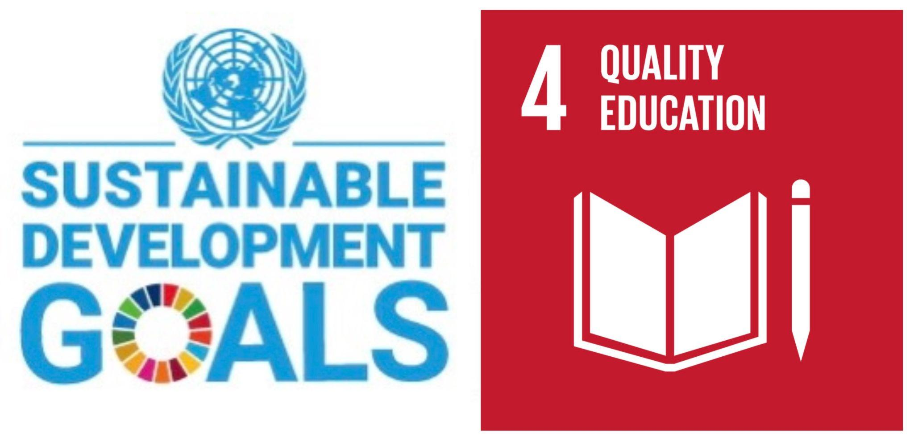

What is the SDGs 4 : quality education
SDGs (Sustainable Development Goals) were set in 2015 and international goals that aim to achieve a suitable and better world by 2030, consisting of 17 goals and 169 targets, and pledging to “leave no one behind” on the planet.
One of the goals of SDGs 4 is that “Provide inclusive, equitable, quality education for all and promote lifelong learning opportunities”. In the world, many children cannot go school and be well-educated due to some reasons.

Q1. According to the last sentence, what are possible causes of this situation?

Q2. According to Q1, what can you do to solve the reasons?

Q3.Why is education necessary for our lives?

Main reasons why children cannot be educated:
1. No school near their homes
2. No teacher
3. Do not have enough money
4. For household
5. To take care of their brothers and sisters
6. Because of their parents’ thought
7. Due to illness/ war

To change this situation and organize an educational environment to nurture human resources for the future, people set SDGs and make an effort on them. Why do they think education is very important for resolution?

Why is quality education needed?
According to the GEFI (Global Education First Initiative) in 2012, Ban Gimun gave 6 reasons.

1 | If all students in low income countries could finish school with a basic level of reading skills, 171 million people would be able to be lifted out of poverty.
2 | If all mothers in low income countries had secondary education, 12 million children would be able to be lifted out of stunting.
3 | If all women had secondary education, the proportion of deaths of children would decrease by 49%.
4 | If all women completed primary education, the deaths of childbirth would decline by 66%.
5 | If all girls had secondary education, there would be 64% fewer child marriages and 59% fewer too early pregnancies.
6 | One year of education in school is related to a 10% increase in their income.

To approach some of the issues of the world, education is one of the essential parts of solutions. Let’s take some examples of countries which cannot establish their education system yet.
Reading Worksheet (40 min)
This part consists of two parts. Read the passage carefully and answer the following questions.

Part1

We have been campaigning on girls’ education through policy dialogues and social media under my Kafka Welfare Organization Pakistan and ILM DOST education campaign Lahore.

Political leaders, members of the parliament, CSOs, media, youth and other stakeholders attended the policy dialogues. Different issues were raised and highlighted during the dialogues and recommendations were established with the help of all stakeholders.

Furthermore, suggestions and key recommendations were presented to political leaders for further implementation through parliament.

All the stakeholders endorsed gender equality education financing, gender equality and equity, the upgrading of girls’ primary schools and the availability of stipends to girls who belong to poor families in order for them to access education.

Participants also agreed to support Kafka’s anti-child marriage campaign. The implementation of a law that prohibits child marriages will eliminate the barrier of early marriages to girls’ education in Pakistan.

Read the statement and answer True or False

Only people who live in rural areas are faced with problems of the gap in girls' education.

One of the reasons that prevents girls from going to school is a force of domestic work.

Generally speaking, most women in Pakistan need to be a housewife who protects or dedicates the family.

Thanks to the new policy of the government, every girl may go to school for free.

The prohibition of child early marriages will promote education for girls.

Part2

Education in Pakistan

Gender equality in education should be a priority which cannot be neglected. There is a need to achieve gender equity because of the existing gaps in girls’ education.
Pakistan is a clear example of a country which has been struggling to achieve gender equality in education. 13 million girls are out of school – this is the total population of some countries.
I have a question. Why is the country facing such crises in girls’ education? The answer is complicated.

Firstly, historically, girls have not been encouraged to seek education in South Asia due to cultural taboos and barriers. A lot of girls are forced early marriage and women join a household based on Islam. More recently, things have started to change and, to some extent, people have started to think outside of the box.

Many parents have started to support education for their daughters. However, other issues have arisen. Unfortunately, girls living in rural areas have to suffer further challenges to access education and in many cases are victims of poverty.

Challenges to girls’ education are not only present in rural areas of Pakistan. The metropolitan city of Lahore is also suffering challenges regarding girls’ access to education.
Approximately 150,000 girls are out of school in Lahore district and the biggest challenge is the absence of quality education.

Some of the challenges that have been identified which impede girls’ access to education are lack of hygienic facilities, the lack of transport, poverty, wrong religious perceptions, gender discrimination, early marriages, lack of education infrastructure, absence of safe environments and physical disabilities.

We will now explore some of these challenges in detail.

Read the following passage and answer the questions by selecting words or phrases in the box.

Education in South Sudan

One/ Twenty five / Eighty/Sixty/ Destroyed/ Refugees/ Free/ Lack of classroom/Thirty/Ten/Expensive/ Built / Citizen

Issues
In 2011, it is estimated that more than (1. )percent of the South Sudanese population cannot read or write. The challenges are particularly severe for female children. South Sudan has proportionately fewer girls going to school than any other country in the world. According to UNICEF, fewer than (2. ) percent of girls complete primary education. Education is a priority for the Southern Sudanese and they are keen to make efforts to improve the education system.

Primary education
As of 1980, South Sudan had approximately 800 primary schools. Many of these schools were established during the Southern Regional administration (1972-81). The Second Sudanese Civil War (1983-2005), (3. ) many schools, although the SPLA operated schools in areas under its control. Nevertheless, many teachers and students were among the (4. ) fleeing the ravages of war in the country at that time. Today many of the schools operate outside in the open, or under trees, due to (5. ). Primary education is (6. ) in public schools to South Sudanese citizens between the ages of six and thirteen years.

ravage:cause severe and extensive damage to.

Discussion Worksheet (15 min)

Write down any of your opinions and ideas through the reading lecture.

Share your opinions with your group members and write down your friends ideas.

What can you do for targets of SDGs 4 from now on to sustain our future globe? Discuss with your group members.

Listening Material (10 min)

Watch a video below and fill in the blanks in the script using less than three words.

▶︎link here. https://youtu.be/4HXyJmY--gM

Everyone deserves the right to a (1. ), with access to trained teachers, learning resources and (2. ) beyond basic literacy and
numeracy skills. When we learn about the world around us and our place in it, we can create a world where everyone is equal. But while more students have (4. ) than ever before, the quality of the education varies widely across the world. That’s why the UN have made quality education for all one of their 17 Sustainable Development Goals.
When children are able to learn, they grow to provide for themselves and become (5. ) of their community. Through education, their minds and imaginations evolve. They become (6. ), analytical, and are given the best possible start in life. In some parts of the world, lots of money is spent on making sure that schools have access to the Internet, computers, books, and everything they need to help students learn.

(omitted)

(2:07~) The UN are working with governments and charities to build (7. ) in developing countries and provide safe spaces where students can learn about creating (8. ) that help the planet and develop technical and trade skills for future (9. ). We can continue this great work together in achieving quality education for all by 2030.

Answers

Overall lecture
Predicted answer
Q1. Economical issues, no access to schools, priority their work than study, and so on
Q2. Economical supports from developed countries, build more school, tell the importance of education to their parents
Q3. For the purpose of quality of life, to become more safety and comfortable society, to develop each countries

Reading Part
Part.1
- F
- F
- T
- F
- T

Part.2
- Eighty
- One
- Destroyed
- Refugees
- Lack of classroom
- Free
Listening Part

1. quality education

3. opportunities

4. access to school

5. valuable members

6. creative

7. schools and libraries

8. sustainable lifestyle

9. employment

References
Pakistan:https://theirworld.org/news/pakistan-girls-education-crisis-gender-equality-priority-in-schools/#:~:text=Some%20of%20the%20challenges%20that,safe%20environments%20and%20physical%20disabilities.

South Sudan:Education in South Sudan | K12 Academics

THE GLOBAL GOALS (2022) ENSURE INCLUSIVE AND EQUITABLE QUALITY EDUCATION AND PROMOTE LIFELONG LEARNING OPPORTUNITIES FOR ALL.
Goal 4: Quality education - The Global Goals

Theirworld (2014) 10 reasons why children don’t go to school

10 reasons why children don’t go to school (theirworld.org)

Claire Melamed (2015) Leaving no one behind: how the SDGs can bring about real change
Leaving no one behind: how the SDGs can bring about real change | ODI: Think change

United Nations (2020) Goal 4: Ensure inclusive and equitable quality education and promote lifelong learning opportunities for all
Goal 4: Ensure inclusive and equitable quality education and promote lifelong learning opportunities for all — SDG Indicators

THREE WEB (2015) 持続可能な開発は教育から
持続可能な開発は教育から

