SDGs 7 Affordable and clean energy
Reading
Section 1:You should spend approximately 20 minutes

SDG 7 Affordable and Clean Energy
There is an increased concern in the literature about unsustainable energy practices and potential effects on vulnerable community groups, particularly on women and girls. This study explores how women can boost their assets and capacities to cope with the impact of unsustainable energy consumption, such as the use of pollutants and waste, the use of fossil fuels, inadequate compensation for the loss of livelihood options, and lack of corporate accountability for adverse unsustainable energy practices. In practicality, the international community and local stakeholders (higher education institutions, the private sector, governments, and civil society organizations) have joint efforts to build women’s capacity by delivering technical assistance pro- grams under the umbrella of the Sustainable Development Goals (SDGs), particularly SDG 7 Affordable and Clean Energy.
SDG 7 Affordable and Clean Energy ensures access to affordable, reliable, and sustainable energy and is crucial in achieving many of the SDGs – from poverty eradication via advancements in health, education, water supply, and industrialization to mitigating climate change. Research shows that existing capacity-building approaches to energy do not strategically target women and fail in incorporating priority capacity-building areas valuable for women. However, these efforts represent a potential for fostering sustainable energy consumption patterns and therefore overall sustainability.
Investing in capacity-building and education structures that boost women’s capacities in line with a vision for greater access to affordable, reliable, and sustainable energy for women further facilitates sustainable livelihood development and access to the rewards of the fulfillment of global goals. This manuscript argues that boosting women’s capacities to cope with the effects of increasing unsustainable energy consumption can foster overall sustainability in the long run. Based on a comparative case study methodology, the research reported in this manuscript identifies priority capacity-building areas valuable for women. It proposes a capacity-building approach for sustainability in selected case studies. Some of the women participants in this study are based in locations where eWisely (Exceptional Women in Sustainability) operates. Wisley is the largest connector of women in sustainability with nearly 8000 leaders and followers in +60 locations. This research has also been supported by Research wisely Lab.

Questions 1-6

SDG 7 Affordable and Clean Energy
SDG 7 Affordable and Clean Energy ensures an approach to 1_______, reliable, and sustainable energy, which is essential to 2________ many of the SDGs. The survey illustrates that existing 3_______ building approaches to energy does not strategically aim to 4_______ and do not incorporate priority capacity-building areas of value to females. On the other hand, these efforts indicate 5________ to foster sustainable energy consumption patterns and, namely, the entire 6________.

Questions 7-9
Do the following statements agree with the claims of the writer?
In boxes 7 - 9 on your answer sheet, write
TRUE if the statement agrees with the claims of the writer
FALSE if the statement agrees with the claims of the writer
NOT GIVEN if it is impossible to say what the writer thinks about this

7 Nowadays, gender equality is focused on more than before so that is why focus on women in this article.

8 Investing in capacity building and educational structures to empower women can further promote sustainable livelihood development and access to achieving global goals.

9 We should think about it more deeply and take in some realistic treatment to support these kinds of movement

Section 2: You should spend about 30 minutes
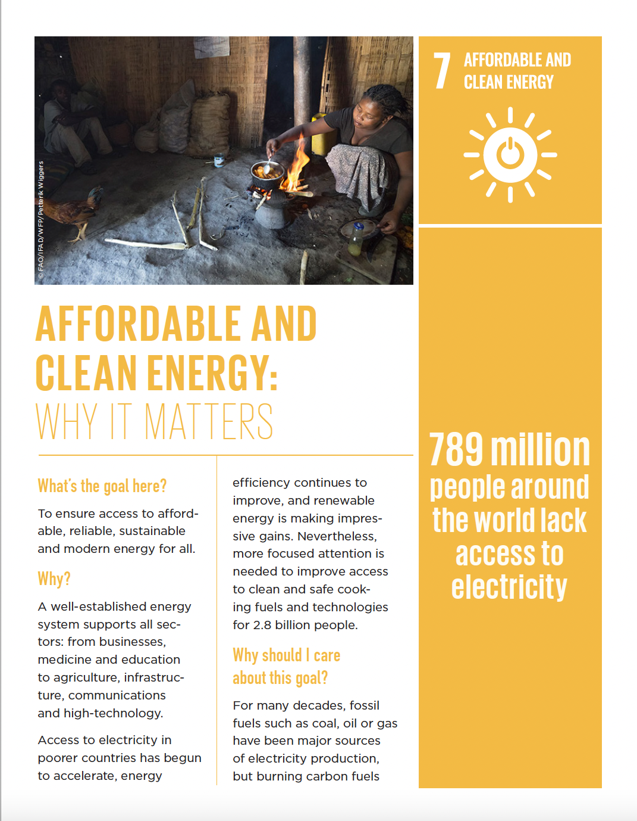

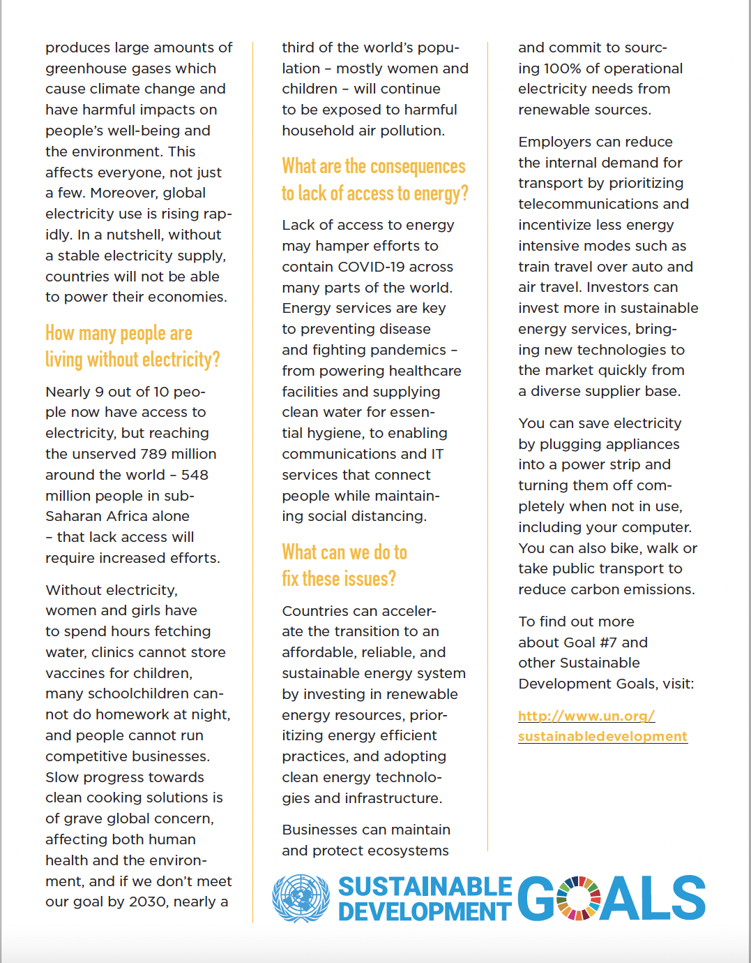

Questions 10-14
Answer the following questions. If the question has a blank, fill in the blank.
Write down your answers by sentence for question number 11, 12, 13, and 14.
10 The No.7 of SDGs is _______ and _______ energy
11 What is the goal here?
12 What is the real situation that people are facing without electricity? Find some examples from this material.
13 What is the source which causes large amounts of greenhouse gas emissions?
14 What will happen if we don't meet our goal in 2030?

Questions 15-17
Do the following statements agree with the claims of the writer?
In boxes 7 - 9 on your answer sheet, write
TRUE if the statement agrees with the claims of the writer
FALSE if the statement agrees with the claims of the writer
NOT GIVEN if it is impossible to say what the writer thinks about this

15 Greenhouse gasses are deadly gasses that could kill humans.

16 More focused attention is not necessarily needed to upgrade ways of clean and safe cooking fuels and technologies for large numbers of people.

17 Employers can cut down the internal requirements for transport by prioritizing telecommunications and incentivizing less energy-intensive modes.

Writing Section

You should spend 20 minutes on this task. Write at least 150 words.

This picture shows some information about affordable and sustainable energy.

Summarize the information by selecting at least 3 of the main features, and make comparisons where relevant.

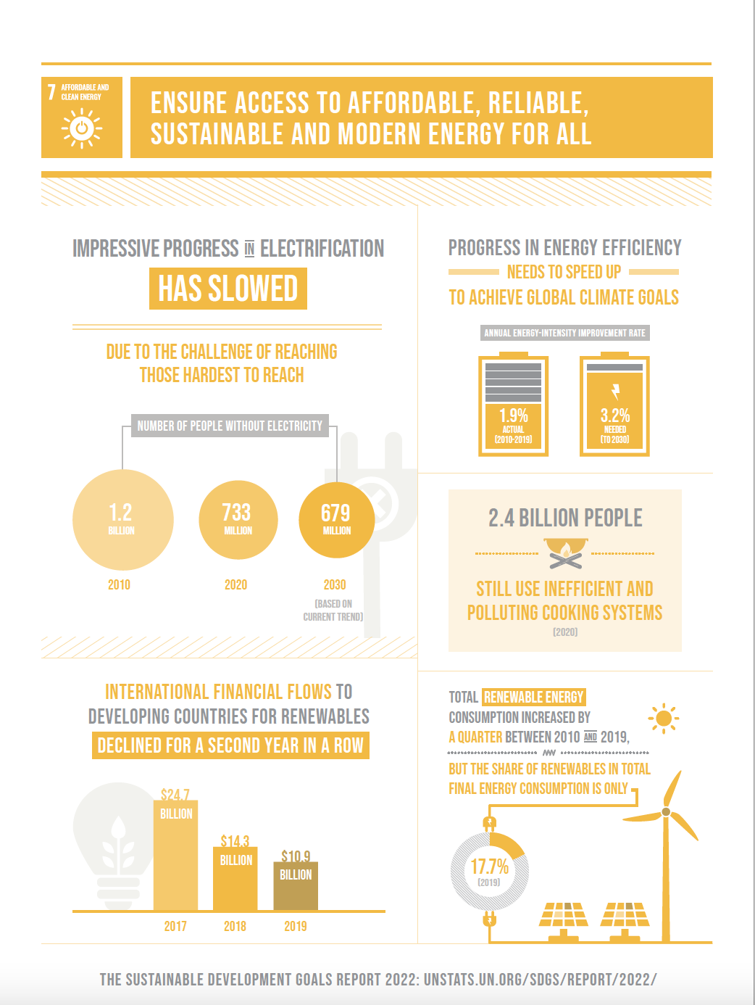

Speaking Section

Part 1
Sustainable energy
・Do you have any ideas about affordable or sustainable energy?
・What methods to make electricity should be focused on more?
・Why do you think sustainable energy is getting so much attention?
・Are there any differences in the way of generating energy in the past and now?

Part 2
Describe an environmental problem that is the most serious recently.
You should say:
what is it
why do you think
how to solve the problem
and explain by using some examples.

Part 3
Discussion topics: Pollution

1. Who do you think is more responsible for pollution, individual people or the government? Explain.
2. Do you know about any anti-pollution programs in your community?
3. Are companies more or less environmentally responsible now than they were in the past?
4. What types of energy are popular in your native country?
5. What are some ways energy is wasted?

Listening Section

You will watch a video related to SDGs 7. Identify words and write short summaries.
You should spend 10 minutes
This is the video☟
https://youtu.be/jlWfQoycRPE

Write a summary of the listening material above(approximately 100 words):

Answers
1 affordable
2 achieving
3 capacity
4 women
5 potential
6 sustainability
7 Not Given
8 True
9 Not Given
10 affordable, clean
11 To ensure access to affordable, reliable, sustainable and modern energy for all.
12 Without electricity, women and girls have to spend hours fetching water, clinics cannot store vaccines for children, many schoolchildren can- not do homework at night, and people cannot run competitive businesses.
13 Burning carbon fuels.
14 Nearly a third of the world's population, mostly women and children will continue to be exposed to harmful household air pollution.
15 Not Given
16 False
17 True

Citation
https://www.researchgate.net/profile/Natalia-Cano/publication/337259356_SDG_6_Clean_Water_and_Sanitation_Sustainable_Use_of_Energy_and_Water_Resources_in_the_Mining_Sector_A_Comparative_Case_Study_of_Open-Pit_and_Alluvial_Mining_Technology/links/5e259d25299bf1cdc4d56924/SDG-6-Clean-Water-and-Sanitation-Sustainable-Use-of-Energy-and-Water-Resources-in-the-Mining-Sector-A-Comparative-Case-Study-of-Open-Pit-and-Alluvial-Mining-Technology.pdf#page=113

Made by

Mizuki Tanaka, Skylan Anthony, Kodai Takahashi, Koki Yamanaka, Ryota Uga

