Global Innovation Studies

Open Lesson Plans for SDGs
Goal 2: Zero Hunger
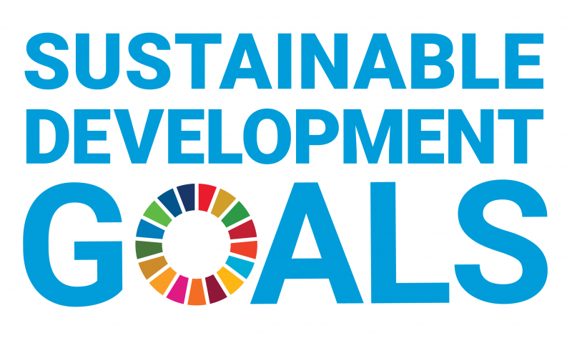

Introduction
“Zero hunger” is one of the 17 Sustainable Development Goals established by the United Nations in 2015. The mission statement is that
“End hunger, achieve food security and improved nutrition and promote sustainable agriculture.”

Reo, Rinno, Ryo, Ryosuke, Ryotaro and Soma

Growing the world population
The concentration of global population growth is in the poorest countries, according to World Population Prospects: The 2017 Revision, presenting a challenge as the international community seeks to implement the 2030 Sustainable Development Agenda, which seeks to end poverty and hunger, and preserve the planet.

“With roughly 83 million people being added to the world's population every year, the upward trend in population size is expected to continue, even assuming that fertility levels will continue to decline,” said the report's authors at the UN Department of Economic and Social Affairs. At this rate, the world population is expected to reach 8.6 billion in 2030, 9.8 billion in 2050 and surpass 11.2 billion in 2100. The growth is expected to come, in part, from the 47 least developed countries, where the fertility rate is around 4.3 births per woman, and whose population is expected to reach 1.9 billion people in 2050 from the current estimate of one billion. In addition, the populations in 26 African countries are likely to “at least double” by 2050, according to the report. That trend comes despite lower fertility rates in nearly all regions of the world, including in Africa, where rates fell from 5.1 births per woman from 2000-2005 to 4.7 births from 2010-2015.

In contrast, the birth rate in Europe was 1.6 births per woman in 2010-2015, up from 1.4 births in 2010-2015. “During 2010-2015, fertility was below the replacement level in 83 countries comprising 46 per cent of the world's population,” according to the report. The lower fertility rates are resulting in an ageing population, with the number of people aged 60 or over expected to more than double by 2050 and triple by 2100, from the current 962 million to 3.1 billion.

Africa, which has the youngest age distribution of any region, is projected to experience a rapid ageing of its population, the report noted. “Although the African population will remain relatively young for several more decades, the percentage of its population aged 60 or over is expected to rise from five per cent in 2017 to around nine per cent in 2050, and then to nearly 20 per cent by the end of the century,” the authors wrote.

In terms of other population trends depicted in the report, the population of India, which currently ranks as the second most populous country with 1.40066 billion inhabitants, will surpass China's 1.4486 billion citizens, by 2024. By 2050, the third most populous country will be Nigeria, which currently ranks seventh, and which is poised to replace the United States.

Do the following statements agree with the information given in the Reading passage?

TRUE if the statement agrees with the information
FALSE if the statement contradicts the information
NOT GIVEN if there is no information on this

1 The World Population Prospect has improved the world hunger situation.
2 It is projected that the world population will increase even if the growth of the birth rate is seen.
3 The fertility rate has risen in Africa in recent years.
4 Today, there are many youngsters in Africa, however they will comprise the most of the total nations by 100 years.
5 Up until now, China’s population has increased significantly, but India is expected to exceed China’s population.

World population to hit 9.8 billion by 2050, despite nearly universal lower fertility rates – UN | | 1UN News

Modern agriculture has many complex challenges

Farming is a complex, unpredictable and individual business. Farmers must meet the changing needs of our planet and the expectations of regulators, consumers, and food processors and retailers. There are increasing pressures from climate change, soil erosion and biodiversity loss and from consumers’ changing tastes in food and concerns about how it is produced. And the natural world that farming works with – plants, pests and diseases – continue to pose their own challenges. While modern agriculture provides a large number of solutions, the outcome is not always the same because each farm is unique: different landscapes, soils, available technology and potential yields.

Farmers must adapt to climate change. The effects of climate change affect farmers’ ability to grow the food we all need. Increasingly volatile weather and more extreme events – like floods and droughts – change growing seasons, limit the availability of water, allow weeds, pests and fungi to thrive, and can reduce crop productivity. Soil erosion is reducing the amount of land available for agriculture, and declining biodiversity affects the pollination of crops. At the same time, farmers are under pressure to conserve water and use fewer agricultural inputs. As they adapt to these changes, farmers also need to mitigate the greenhouse gas emissions contributed by agriculture through adopting climate-smart practices – a new learning journey for many.

Consumer needs and expectations drive the food value chain. Farmers need to meet rising demand for more food of higher quality. In recent years, there has been a shift in focus from concern about ‘enough food’ to ‘good food’. Society has rising expectations of farmers to reduce their impact on the environment, to increase the nutritional content of crops and to further minimise chemical residues in crops and the environment.

Farming is a business. Agtech, or agricultural technology, is raising crop productivity, but farmers need to invest in such technology, from treated seeds and crop protection products to data-analysis apps and precision spraying. While large-scale farmers may be able to afford to invest, smallholders don’t always have access to an affordable source of credit. And then farmers must learn how to best use these technologies to improve their business. A farmer’s business decisions are complicated by global economic factors, like fluctuating commodity prices and trade issues, and the fact that a harvest can be affected by weather, insects or disease. There’s also the question: who is going to farm in the future? As millions of people from rural areas migrate to cities each year, farmers need to inspire enough of them to remain and build a career in agriculture.

Complete the summary below.

Choose NO MORE THAN TWO WORDS from the passage for each answer.
Write your answers in boxes 6-10 on your answer sheet.

What kind of problems do farmers face?
Farmers need to deal with many problems, including how to:
・Cope with climate change, 6………… and biodiversity loss
・Satisfy consumers’ changing tastes and expectations
・Meet rising demand for more food of 7…………..
・8…… in farm productivity
・Adopt and learn new technologies
・Stay resilient against 9…………… factors
・Inspire young people to stay in 10……….. and become future farmers

Challenges for modern agriculture | Syngenta

Climate Change Could Affect Global Agriculture Within 10 Years

Complete the notes below.

Listen to the video and Write LESS THAN THREE WORDS for each answer.

・NASA suggested that we will see a reduction of 11…………………… by high greenhouse gas emissions.
・Corn gets stressed from rising temperatures in the region that is 12.…………………… .
・Corn yields 13…………………… on the other hand, wheat yields 14…………………… due to global warming.
・By likely 15…………………… increase of wheat crop yields will settle down.

Planetary boundary

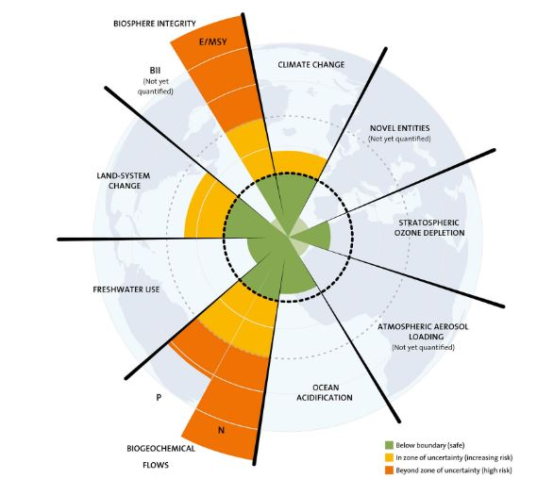

1 biogeochemical flows: the pathways by which elements like phosphorus, nitrogen, flow between living organisms and the environment
2 P… phosphorus AND… nitrogen

Genetic diversity
Functional diversity

Summarise the information and by selecting and reporting the main features, and make comparisons where relevant. Please include what you have already known and how it can possibly affect our future.

16
You should spend about 20 minutes on this task.
Write at least 150 words.

What test takers should write;
1 what they learned from the reading section
2 at least one section that relates to No Hunger
3 at least one thing they have already known about the planetary boundary

Describe what you have done in order to reduce hunger.
If you have not done anything, describe what you plan to do in the future.

17
You should say:
what you did
when you did
how long you did it for
and explain how it will help people.

What are the differences between developing and developed countries regarding agriculture?

18 Do you think farming is important?
19 Do you think climate change is influencing food production in any way? Why?
20 How will technological and scientific improvements affect food production?

Answers
1, NG 2, T 3, F 4, F 5, NG

6. soil erosion
7. higher quality
8. Invest
9. global economic
10. rural areas

11. global crop yield
12. close to the equator
13. decrease
14. increase
15. 2050 (or so)

Model answer
16
Requirements

1 There are increasing pressures from climate change, soil erosion and biodiversity loss and from consumers’ changing tastes in food and concerns about how it is produced
2 It can be seen that phosphorus and nitrogen release is a huge concern and it seems to go beyond the zone.
3 One of the significant sectors in this planetary boundary is biology diversity. It says, genetic diversity is significantly being lost. (It seems that due to the increase of human population causing loss of their habitats)

