What’s after SDGs?
Gender Equality in the workplace

-We think that SDG 5, Gender Equality, is a high possibility to achieve until 2030, in comparison with other goals. Then, we should consider how to improve it after achieving, after 2030.

Miyabi, Haruna, Karin, Yui, Kinari, Ami

Listening (15 mins)
Listen to the below TED talk. Then answer the multiple questions

Sara Sanford “How to design gender bias out of your workplace”
https://www.ted.com/talks/sara_sanford_how_to_design_gender_bias_out_of_your_workplace/transcript?language=en

Q1. What based on when women are evaluated in year course evaluation?
A. Behavior
B. Appearance
C. Work
D. Working hour
Q2. For how many years extended the assumption that the gender pay gap would be closed?
A . 25 years
B. 30 years
C. 55 years
D. 60 years

Writing (20 mins)
Q: Have you ever faced discrimination related to gender differences? If you have, describe the situations of that and what you felt by facing the incident.
Additional work : How can organizations effectively implement the principles discussed in Sara’s TED talk to create a more inclusive and gender bias-free workplace?

Write your idea in around 200 words

Reading (15 mins)
Read below article: Make a pair. Read the different articles with your partner.
Wage and working hours

A major cause of gender wage disparity among regular employees in Japan is the dearth of female managers. According to the 2016 Basic Survey on Equality of Employment Opportunity by the Ministry of Health, Labour, and Welfare, women hold 6.4 percent of the positions of department director or equivalent; 8.9 percent of section head or equivalent; and 14.7 percent of task-unit supervisor or equivalent.
As is true elsewhere, Japan’s non-regular employees have nearly uniformly low wages, irrespective of age and gender. For regular employees, on the other hand, wages increase with age until the employee reaches approximately 50 years old. This is because in a large majority of Japanese firms, regular employees receive wage premiums based on years of service. The gender disparity in the proportion of non-regular employees is perpetuated by the employers’ perception that new graduates are more desirable candidates for regular employment. Because employers tend to prioritize the hiring of these younger job seekers for regular employment, women who leave their jobs for childrearing and attempt to re-enter the job market at a later date have very limited opportunities for regular employment.

Women population in leader position

A survey on the promotion of women in companies, conducted by Teikoku Databank in July 2021 and targeting 24,285 companies across Japan, revealed that the ratio of female managers overall had increased by 1.1 points from the previous year to 8.9%. This was the highest ratio since this survey began in 2013. However, the government had set a goal of having at least 30% of women in leadership positions in political, economic, and similar fields by 2020 and this has not yet been achieved. Their aim has now been revised to “achieving around 30% as soon as possible in the 2020s.” In the survey this time, only 8.6% of companies had more than 30% women in managerial positions, while 45.2% had no female managers at all. This shows the gulf between the government goal and Japanese society today.

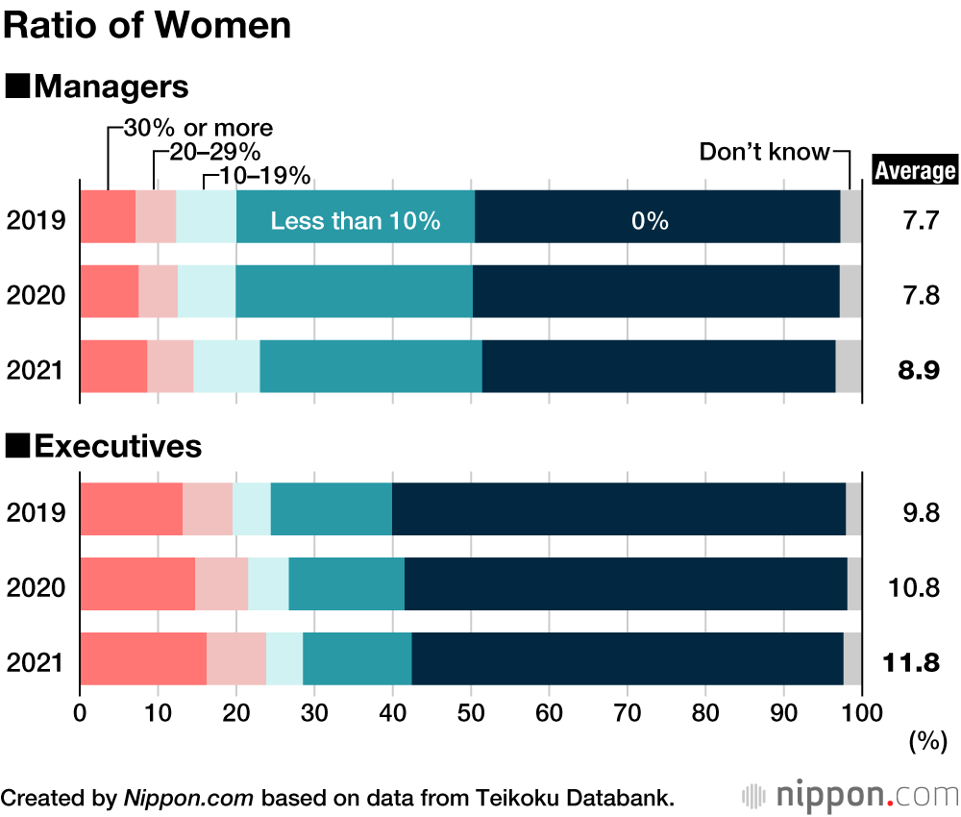

Speaking (10 mins)

Discuss what you read and your opinions from reading
The article that you are reading is different from the article that your partner is reading. Let’s share what you’ve read with your partner and your ideas about articles that you read!

Listening part answer

Q1, A
Q2, D

References
Listening material
Sanford S, 2018, “How to design gender bias out of your workplace”, TedTalks
https://www.ted.com/talks/sara_sanford_how_to_design_gender_bias_out_of_your_workplace/transcript?language=en
Reading materials
Yamaguchi, Kazuo. 2011. “Decomposition of Inequality among Groups through Counterfactual Modeling:An Analysis of the Gender Wage Gap in Japan.” Sociological Methodology 43:223-55.
2016. “Determinants of the Gender Gap in the Proportion of Managers among White-Collar Regular Workers in Japan.” Japan Labor Review 51:7-31.
Forthcoming. Gender Inequalities in Japanese Workplace and Employment—Theories and Empirical Evidence . Springer. Second paragraph
https://www.imf.org/en/Publications/fandd/issues/2019/03/gender-equality-in-japan-yamaguchi
Japan Data. (2023, August 31). Government target of 30% female managers still far from achieved in Japan. Ratio of Female Managers Creeps up to 9.8% in Japan. https://www.nippon.com/en/japan-data/h01766/

