Listening section
What is SDGs
Watch the video and answer each question.
There are some different questions, so you need to answer properly.
SUSTAINABLE DEVELOPMENT GOALS 📑🌍 What are SDGs? 👧👦 - YouTube
Q1 Write the correct name of the goal.
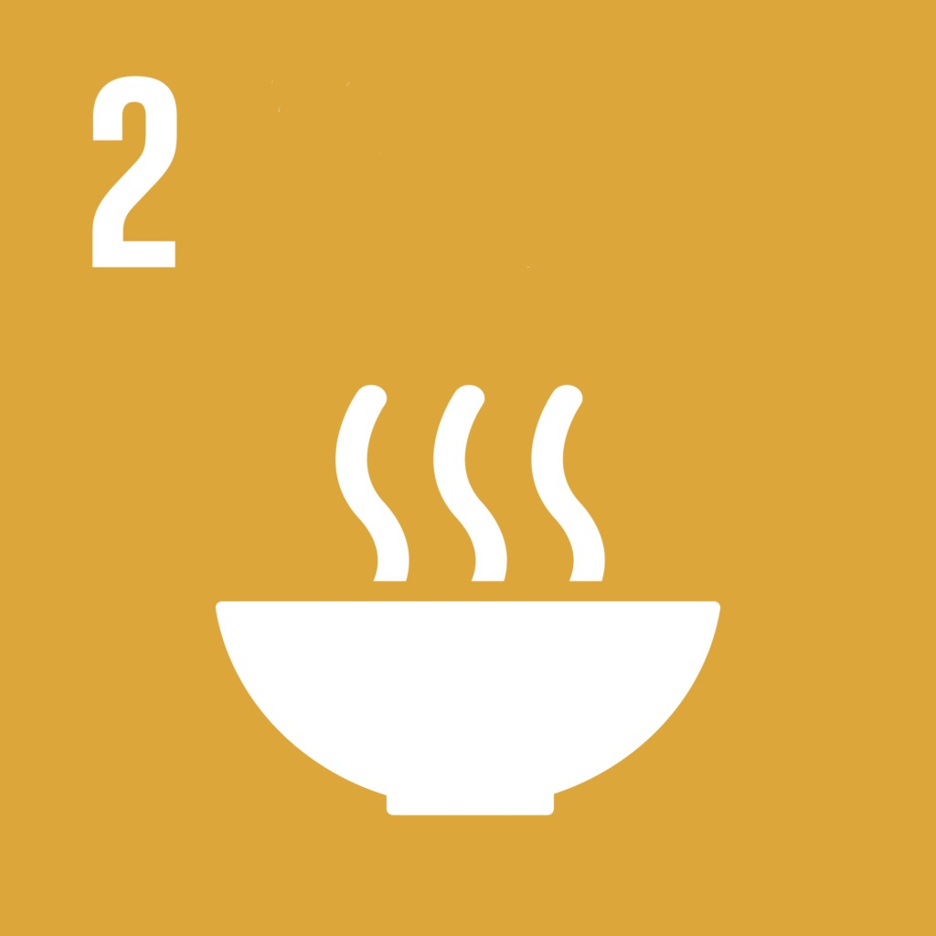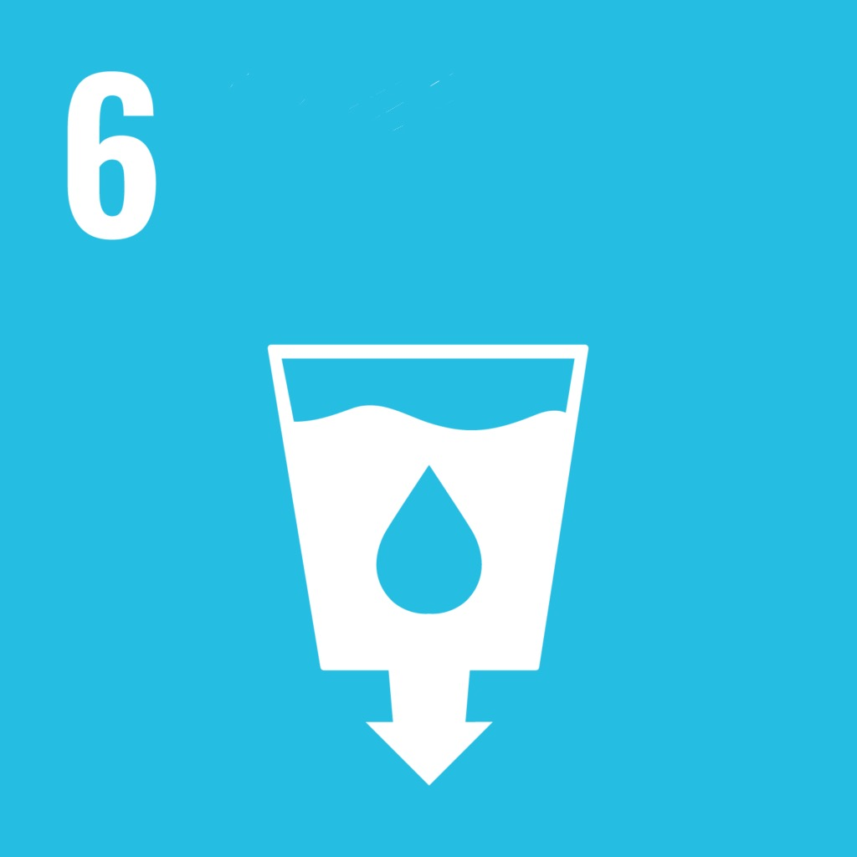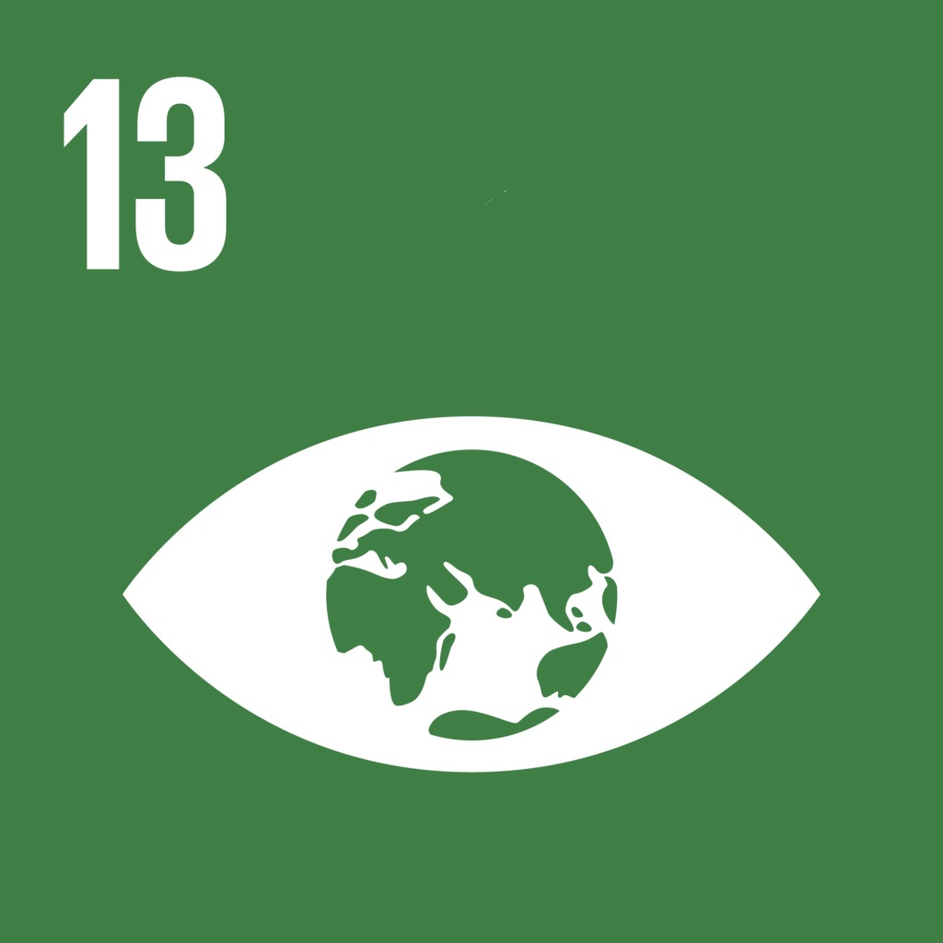
2

6

13

Q2 Which Organization adopted SDGs?
and its member countries.

Q3 Write more than 3 solutions to achieve the goals and to save the Earth, which are shown in the video.

Answer

Q1
・Zero hunger
・Clean water and sanitation
・Climate action

Q2
・The United Nation

Q3
・Turn off the lights if you do not need them and talk with your family about unplugging appliances when they are not using them.
・Take quick showers instead of taking a bath.
・Recycle as many materials as possible.
・Use public transportation or ride a bike.
・Donate things you do not use.
・Use a refillable water bottle.

: Write down the limitation examples of each category
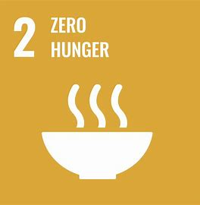
2. Zero Hunger
ex). A lot of food wastes in developed countries

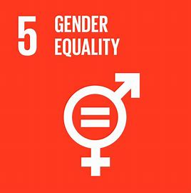
5. Gender Equality
ex). Unconscious stereotypes and bias

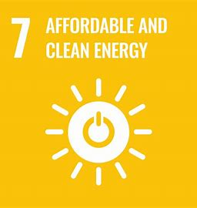
7. Affordable and Clean Energy
ex). More energy generating, more pollution will be produced

Speaking section

Question

Based on these charts, what concerns you about SDGs achievements? Is it possible to achieve them by 2030? Discuss with your group members.

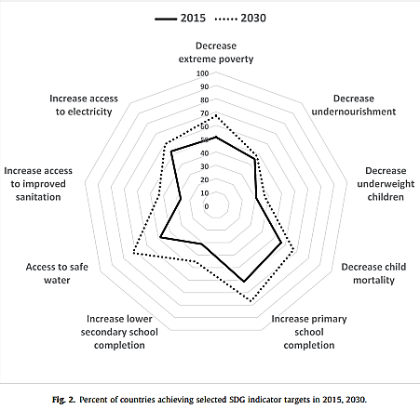
Fig.1 Percent of countries achieving selected SDG indicators in 2015, 2030.

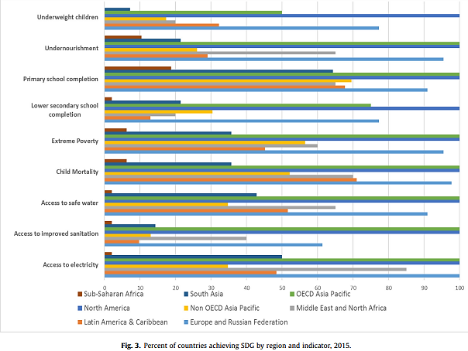

Fig.2 Percent of countries achieving SDG by region and indicators, 2015.

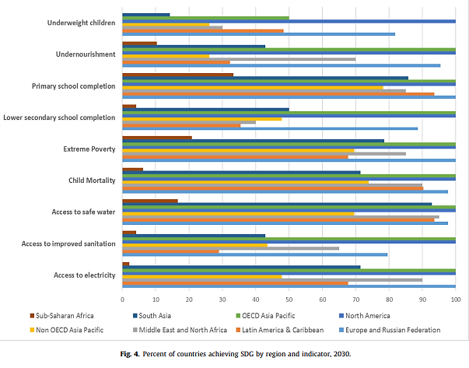

Fig.3 Percent of countries achieving SDG by region and indicators, 2030

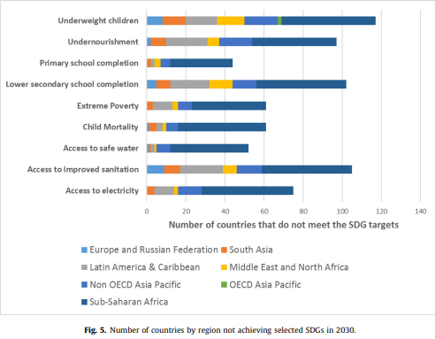

Fig.4 Number of countries by region not achieving selected SDGs in 2030

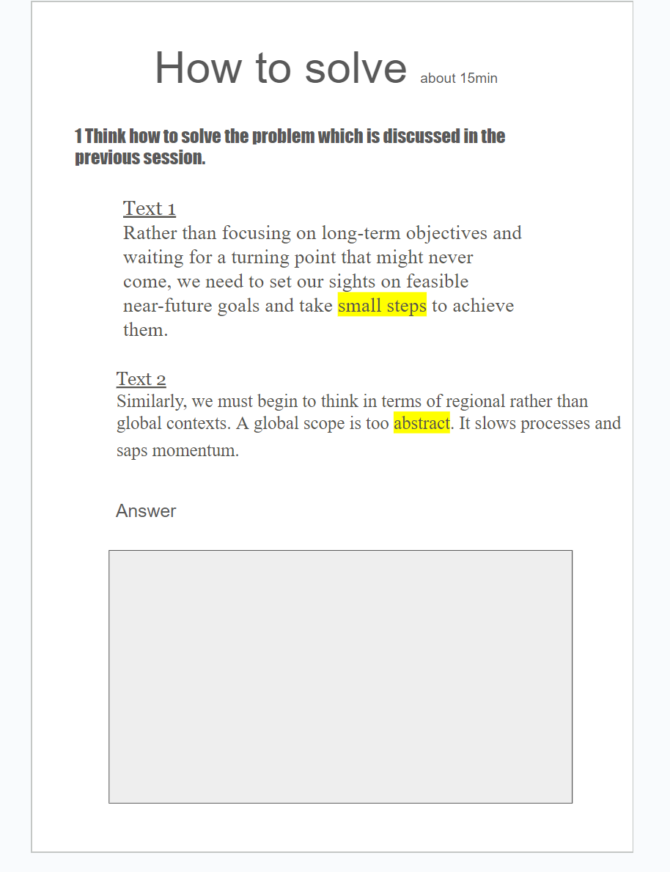

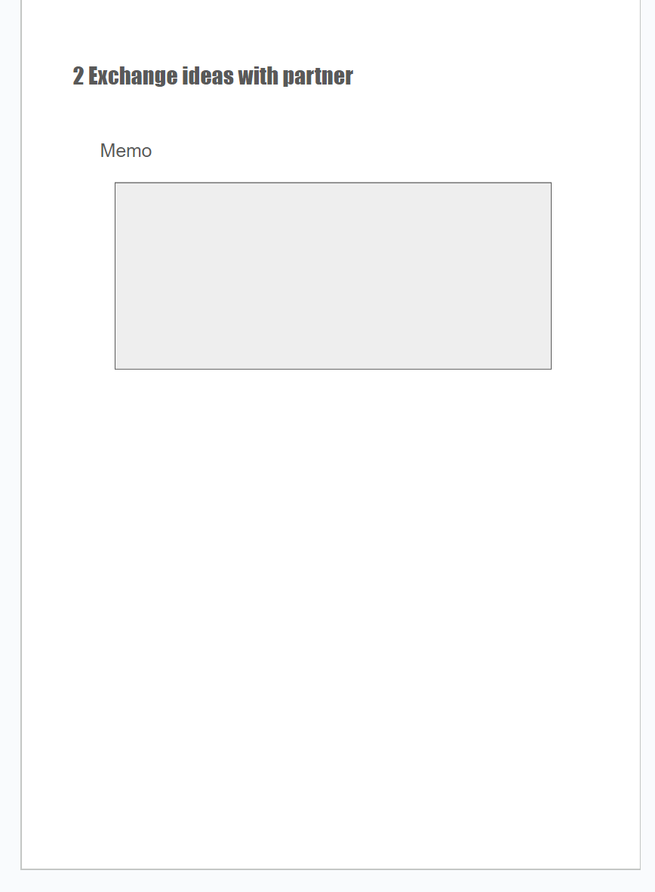

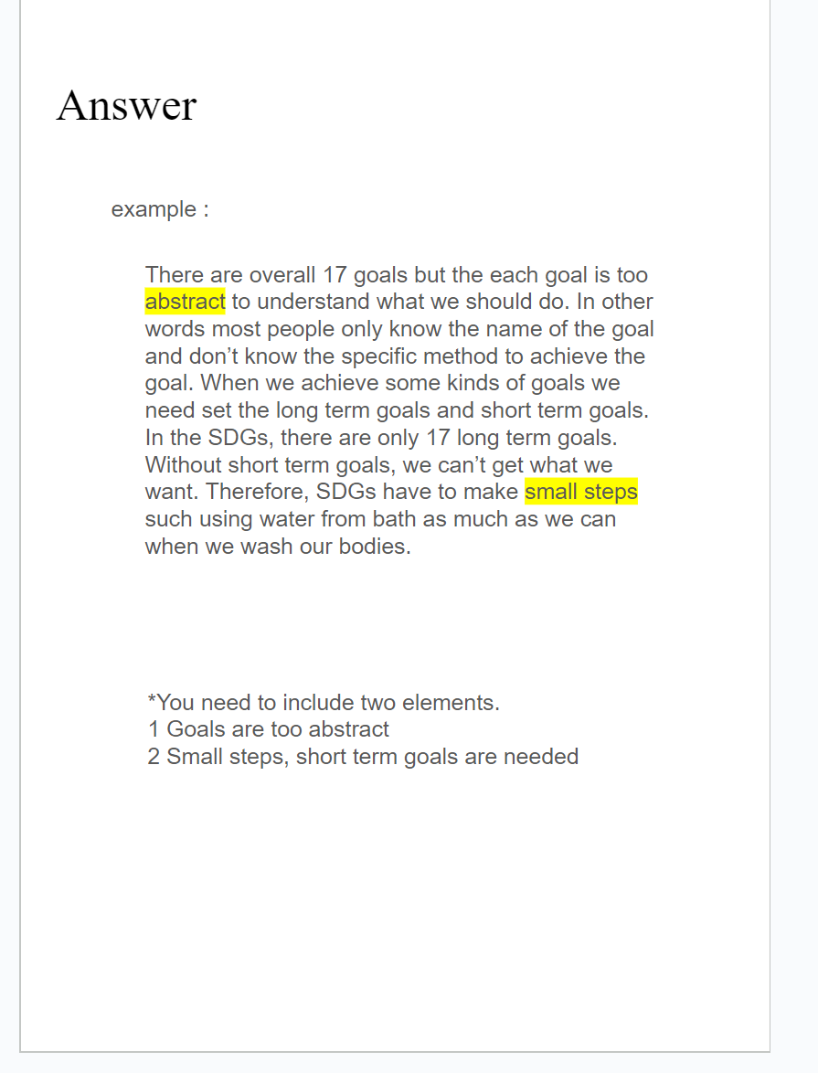

Reading & Writing (15min)
What is the fundamental problem in Indonesia, with regard to children?
How should the SDG limitations be improved? Choose one goal and explain your improvements.

Indonesia is a highly populated and heterogeneous place and the health of its children is challenged by the country’s geographic, demographic, political, socioeconomic, and cultural diversity in many aspects. However, even under such challenging circumstances it remains almost a universal fact that the majority of deaths among children under the age of five can be prevented. The progress towards MDG 4 in Indonesia is not universal as well is this goals equity-blind and obscures health disparities within different population groups. This review shows that the major determinants of poor child health in Indonesia are subject to the shortcomings of the health system, malnutrition, low health literacy, as well as gender and ethnic inequalities. This work reviews existing evidences and calls for enhanced understanding of the determinants and pathways that produce and overcome inequities in health among a disadvantaged and vulnerable population such as children.

https://journals.plos.org/plosone/article?id=10.1371/journal.pone.0123629

ex) The effects of children’s education for the achievement to goals.

