Economic Growth

What is SDGs?
The 2030 Agenda for Sustainable Development, adopted by all United Nations Member States in 2015, provides a shared blueprint for peace and prosperity for people and the planet, now and into the future. At its heart are the 17 Sustainable Development Goals (SDGs), which are an urgent call for action by all countries - developed and developing - in a global partnership. They recognize that ending poverty and other deprivations must go hand-in-hand with strategies that improve health and education, reduce inequality, and spur economic growth – all while tackling climate change and working to preserve our oceans and forests.

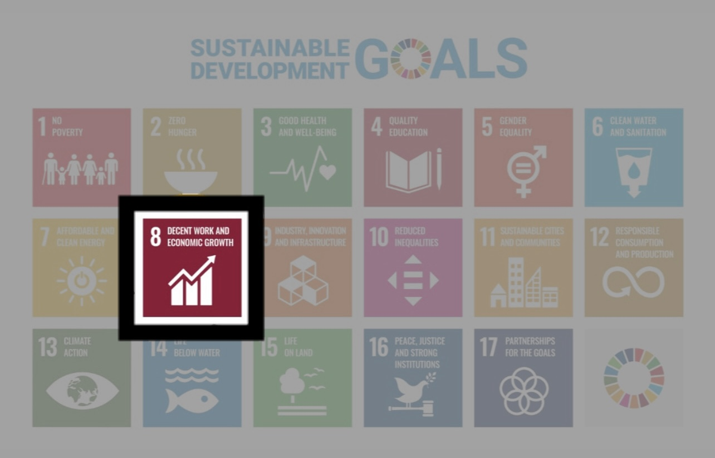

Economic Growth - Reading

Reading Material (30 min)
The chart shows the global history of extreme poverty and economic growth.

In the top left panel, you can see how global poverty has declined as incomes increased; in the other eight panels, you see the same for all world regions separately. The starting point of each trajectory shows the data for 1820 and tells us that two centuries ago, the majority of people lived in extreme poverty, no matter where in the world they were at home.

Back then, it was widely believed that widespread poverty was inevitable. But this turned out to be wrong. The trajectories show how incomes and poverty have changed in each world region. All regions achieved growth – the production and quality of goods and services that people need increased – and the share living in extreme poverty declined.19

This historical research was done by Michail Moatsos and is based on the ‘cost of basic needs’-approach as suggested by Robert Allen (2017) and recommended by the late Tony Atkinson.20 The name ‘extreme poverty’ is appropriate as this measure is based on an extremely low poverty threshold. It takes us back to what I mentioned at the very beginning; this historical research tells us – as the author puts it – that three-quarters of the world "could not afford a tiny space to live, food that would not induce malnutrition, and some minimum heating capacity.”

Since then, all world regions have made progress against extreme poverty – some much earlier than others –, but in particular, in Sub-Saharan Africa, the share living in deep poverty is still very high.
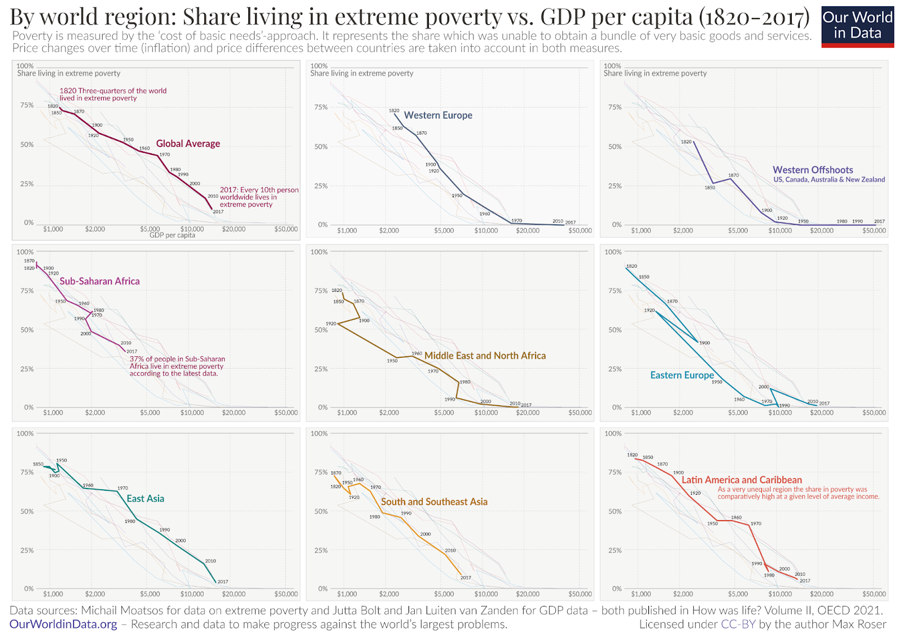

Question
- Many people experienced extreme poverty everywhere two centuries ago.
  - True
  - False

- What was the belief about widespread poverty in the 1820s?
  - People believed that it was quite possible to avoid poverty.
  - Poverty was spread non-stop in the 1820s
  - Although widespread poverty was avoidable, people thought that it was difficult to avoid.

- Which approach did Michail Moatsos use in the historical research on extreme poverty?
  - The wealth distribution model
  - The 'cost of basic needs' approach
  - The expenditures approach

- Which world region(s) does suffer from the highest levels of extreme poverty, according to the research?
  - North America and Europe
  - Sub-Saharan Africa
  - Asia-Pacific region

- 75% of the world could not afford some minimum heating capacity, a small place to settle, ( ) to prevent malnutrition.

Online Materials from
https://ourworldindata.org/what-is-economic-growth

Child Labor - Listening and Discussion

Listening (10 min)

https://www.youtube.com/watch?v=ckz4qccSVpY&pp=ygUhY2hpbGQgbGFib3VyIGluIHRoZSB1bml0ZWQgc3RhdGVz
1.What is the boy transporting?
2.When the boy starts to work?

3.Why they forced to abandon their home?

4.How many children are working as labor in the world?

5.Why the woman hesitates to tell the truth about her real situation? (sentence)

Research activity (20 min)

Special report : Inside the Congo cobalt mines that exploit children - YouTube
(https://www.youtube.com/watch?v=JcJ8me22NVs&pp=ygUhY2hpbGQgbGFib3VyIGluIHRoZSB1bml0ZWQgc3RhdGVz)5

From the above video, we can learn that there are a lot of people who are working in dangerous conditions in african countries, and due to the unsanitary conditions, many people suffering from confections and diseases.
Donation is one of the efficient solutions to save those people who are suffering from poor conditions. Therefore, now let's find out what we can donate to.
And think how much you can donate in a month, or year?

Discussion materials (10 min)

Nowadays, child labour is a hot and controversial topic. African children are in a dangerous working environment. Therefore, when people hear the word of child labour, they would imagine the situation of that in developing countries, especially in African countries. However, some children in developed countries are also working. Some students build their own companies and become CEOs, the others become youtubers.
Do you think that working since they are young is beneficial? If so, what are the advantages? If you don’t think so, why do you think it is worthless?
Clear your position and discuss in your group.

Solution for obstacles toward decent work – Discussion

What approaches should be taken to improve decent work?

(Example)
“Safety + Health for All”

- A program to improve the safety and health of workers worldwide.
  - Knowledge sharing on health and safety
  - Fill in a gap in existing knowledge
  - Promote good practices in occupational health and safety

What approach?

How?

What are the effects?

Working Style

These days, there are a lot of working styles all over the world. Therefore, job satisfaction is different between Japan and other countries. In this essay, we will compare Japan, America and Europe’s working style and satisfaction in each country.

Japanese Style
In Japanese society, companies are trying to improve the workplace environment. Japanese companies reduced working time to less than 100 hours. However, the number of workers who want to contribute to their company and have an aspiration of work is less than 60%. This score is the lowest number in the world. In Japanese companies, people are a lot more important than money or anything else. Japanese emphasise a life-time employment, and the managers are responsible for ensuring a harmony among team members who then contribute to achieving their company’s goals more effectively.

American Style
In America, people’s awareness of work is just the thing to earn money. ”Efficient work" is the most important style for American people. Also, employees' salaries are in proportion to their working outcome, so if they can’t get a good result, they can not get enough money to live. Even in America, there are less companies that admit childcare leave. American people who do not have enough income must come back to work soon. To compare with the Japanese companies, an American company's minimum unit is represented by a job. In other words, American employers focus on preparing the right job descriptions first, and then they try to find the person who can improve the right skills and abilities to meet the requirements needed for a successful performance. Therefore, there are many cases of lays-off happened in America. It seems hard for Japanese people, but it is a normal thing in America. With these complexities, the United States is still searching to find the optimal work-life balance.

Europe Style
What about the European working style next? By OECD in 2015, it was found that Europeans work an average of roughly 300 fewer hours per year than the workers in America. Furthermore, work and private life are increasingly separated and also they can take more vacation time in Europe. The other major difference from America is that European countries have stronger employment protections such as laws that make it more difficult for employers to fire employees without any cause. This is a very different environment than in America where it is easy to end an employment relationship in a meritocracy. In addition, European countries offer generous benefits packages, with a wide variety of parental leave and insurance available. These are funded through taxes. This is one of the reasons why taxes are set higher in European countries.

Quizzes
① Europeans work an average of roughly ＿＿＿ fewer hours per year than the workers in America.

Answer) 300

② " ＿＿＿ work" is the most important style for American people.

Answer) Efficient

③ The reasons why Europeans people can get benefits package is high ____.

Answer) taxes

